**CC 1 SOFTWARE TESTING USING SELENIUM**

**QUESTION 1:**

**package** com.Test.CIA;

**import** org.openqa.selenium.By;

**import** org.openqa.selenium.WebDriver;

**import** org.openqa.selenium.chrome.ChromeDriver;

**import** org.openqa.selenium.chrome.ChromeOptions;

**import** io.github.bonigarcia.wdm.WebDriverManager;

**public** **class** CCQ1 {

**public** **static** **void** main(String args[]) **throws** InterruptedException {

ChromeOptions co=**new** ChromeOptions();

co.addArguments("--remote-allow-origins=*");

WebDriverManager.*chromedriver*().setup();

WebDriver driver=**new** ChromeDriver(co);

driver.get("https://www.saucedemo.com/");

driver.findElement(By.*xpath*("//*[@id=\"user-name\"]")).sendKeys("standard_user");

driver.findElement(By.*xpath*("//*[@id=\"password\"]")).sendKeys("secret_sauce");

driver.findElement(By.*xpath*("//*[@id=\"login-button\"]")).click();

Thread.*sleep*(3000);

driver.findElement(By.*xpath*("//*[@id=\"add-to-cart-sauce-labs-backpack\"]")).click();

driver.findElement(By.*xpath*("//*[@id=\"shopping_cart_container\"]/a")).click();

String AddCart=driver.findElement(By.*xpath*("//*[@id=\"cart_contents_container\"]/div/div[1]/div[3]/div[1]")).getText();

String expCart="1";

**if**(AddCart.equals(expCart)) {

System.***out***.println("Added to Cart Successfully");

}

**else** {

System.***out***.println("Not added to cart");

}

driver.findElement(By.*xpath*("//*[@id=\"checkout\"]")).click();

driver.findElement(By.*xpath*("//*[@id=\"first-name\"]")).sendKeys("Sahana");

driver.findElement(By.*xpath*("//*[@id=\"last-name\"]")).sendKeys("J");

driver.findElement(By.*xpath*("//*[@id=\"postal-code\"]")).sendKeys("641046");

driver.findElement(By.*xpath*("//*[@id=\"continue\"]")).click();

String currCheckout=driver.findElement(By.*xpath*("//*[@id=\"header_container\"]/div[2]/span")).getText();

String expCheckout="Checkout: Overview";

**if**(currCheckout.equals(expCheckout)) {

System.***out***.println("Checkout Text is Matched");

}

**else** {

System.***out***.println("Checkout text is not Matched");

}

String prod=driver.findElement(By.*xpath*("//*[@id=\"item_4_title_link\"]/div")).getText();

System.***out***.println(prod);

String price=driver.findElement(By.*xpath*("//*[@id=\"checkout_summary_container\"]/div/div[1]/div[3]/div[2]/div[2]/div")).getText();

System.***out***.println(price);

String currTitle=driver.getTitle();

String expTitle="Swag Labs";

**if**(currTitle.equals(expTitle)) {

System.***out***.println("Title is Matched");

}

**else** {

System.***out***.print("Title is not Matched");

}

String currUrl=driver.getCurrentUrl();

String expUrl="https://www.saucedemo.com/checkout-step-two.html";

**if**(currUrl.equals(expUrl)) {

System.***out***.println("URL is matched");

}

**else** {

System.***out***.println("URL is not Matched");

}

}

}

**OUTPUT:**

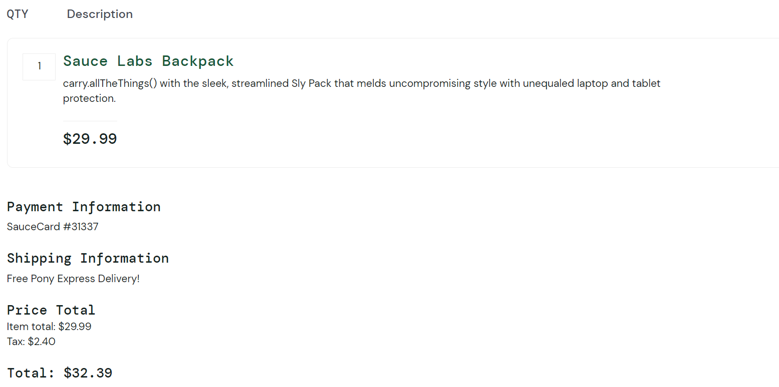

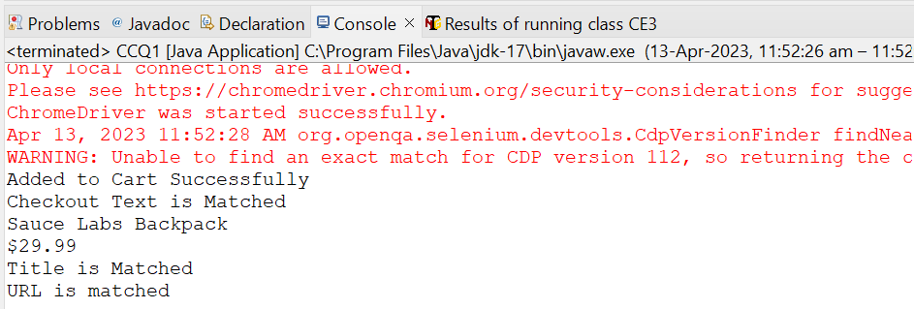

**QUESTION 2:**

**package** com.Test.CIA;

**import** org.openqa.selenium.By;

**import** org.openqa.selenium.WebDriver;

**import** org.openqa.selenium.chrome.ChromeDriver;

**import** org.openqa.selenium.chrome.ChromeOptions;

**import** io.github.bonigarcia.wdm.WebDriverManager;

**public** **class** CCQ2 {

**public** **static** **void** main(String[] args) **throws** InterruptedException {

ChromeOptions co=**new** ChromeOptions();

co.addArguments("--remote-allow-origins=*");

WebDriverManager.*chromedriver*().setup();

WebDriver driver=**new** ChromeDriver(co);

driver.get("https://www.saucedemo.com/");

driver.findElement(By.*xpath*("//*[@id=\"user-name\"]")).sendKeys("standard_user");

driver.findElement(By.*xpath*("//*[@id=\"password\"]")).sendKeys("secret_sauce");

driver.findElement(By.*xpath*("//*[@id=\"login-button\"]")).click();

Thread.*sleep*(3000);

String A_z=driver.findElement(By.*xpath*("//*[@id=\"item_4_title_link\"]/div")).getText();

System.***out***.println("1st Product in A-Z: "+A_z);

driver.findElement(By.*xpath*("//*[@id=\"header_container\"]/div[2]/div/span/select")).click();

driver.findElement(By.*xpath*("//*[@id=\"header_container\"]/div[2]/div/span/select/option[2]")).click();

System.***out***.println("1st Product in Z-A: "+driver.findElement(By.*xpath*("//*[@id=\"item_3_title_link\"]/div")).getText());

driver.findElement(By.*xpath*("//*[@id=\"header_container\"]/div[2]/div/span/select")).click();

driver.findElement(By.*xpath*("//*[@id=\"header_container\"]/div[2]/div/span/select/option[3]")).click();

System.***out***.println("1st Product Price in the range Low to High: "+driver.findElement(By.*xpath*("//*[@id=\"inventory_container\"]/div/div[1]/div[2]/div[2]/div")).getText());

driver.findElement(By.*xpath*("//*[@id=\"header_container\"]/div[2]/div/span/select")).click();

driver.findElement(By.*xpath*("//*[@id=\"header_container\"]/div[2]/div/span/select/option[4]")).click();

System.***out***.println("1st Product Price in the range High to Low: "+driver.findElement(By.*xpath*("//*[@id=\"inventory_container\"]/div/div[1]/div[2]/div[2]/div")).getText());

}

}

**OUTPUT:**

